**Project Work - Student Handbook** 

Project Batch ID:

|  |  |  |  |
| --- | --- | --- | --- |
| **Degree/ program** | B.Tech | **Specialisation** | Computer Science & Engineering - BDA |
| **Academic Year** | 2024-2025 (Even) | **Semester** | 8 |

|  |  |  |
| --- | --- | --- |
| **Name of student** | **Register Number** | **Department** |
| Rahul Dinesh Nair | RA2111027010009 | DSBS |
| Ansab Aalim | RA2111027010030 | DSBS |
| Ishaan Manhas | RA2111027010031 | DSBS |
| Kshitij Rastogi | RA2111027010051 | DSBS |

|  |  |
| --- | --- |
| **Guide** | Dr. A.V. Kalpana |
| **Faculty Advisor** | Dr. K. Archana |

|  |  |
| --- | --- |
| **Project Title** | H₂O GUARDX: A Smart Framework for Water Safety Using ML, Blockchain & XAI |
| **Sustainable Development Goal (SDG)** | SDG- 6[Clean water and sanitation](https://globalgoals.org/goals/6-clean-water-and-sanitation/) |

|  |  |
| --- | --- |
| **Conference Details** |  |
| **Theme** | *Adopting Innovation and Transformation to Achieve Sustainable Development Goals* |
| **Date** | 11.02.2025 & 13.02.2025 |
| **Venue** | Online |
| **Organized By** | *ICEARS 2025* |

*Invite:*

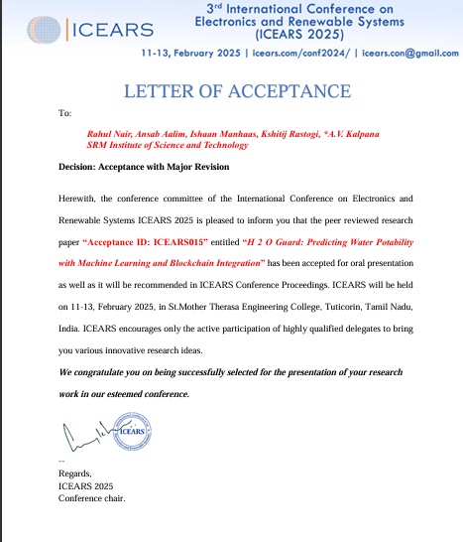

*Copy Transfer Confirmation:*

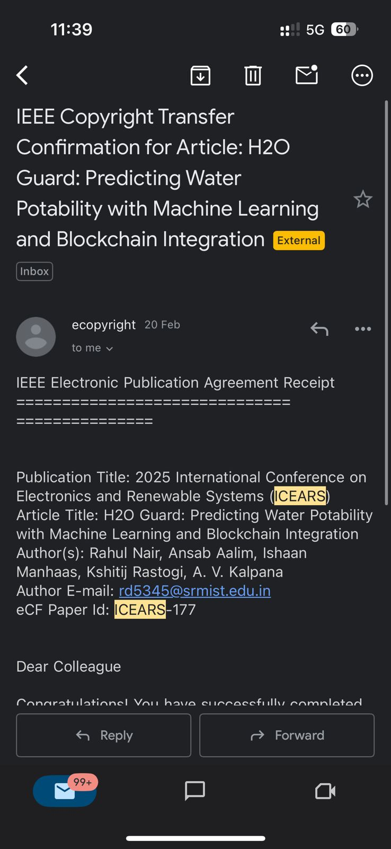

*Certificates:*

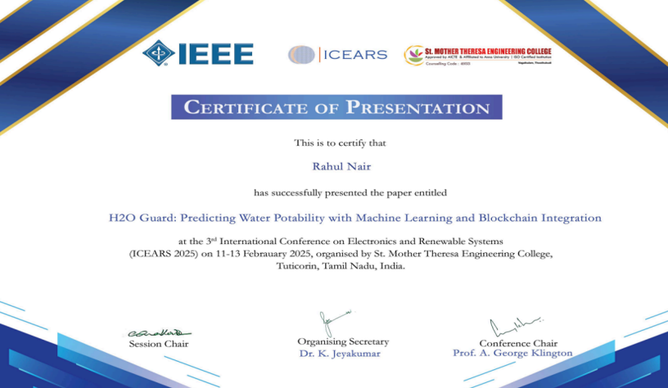

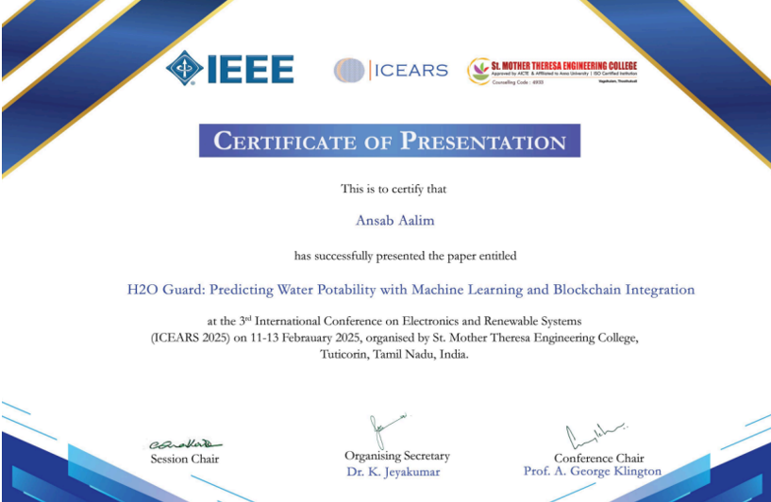

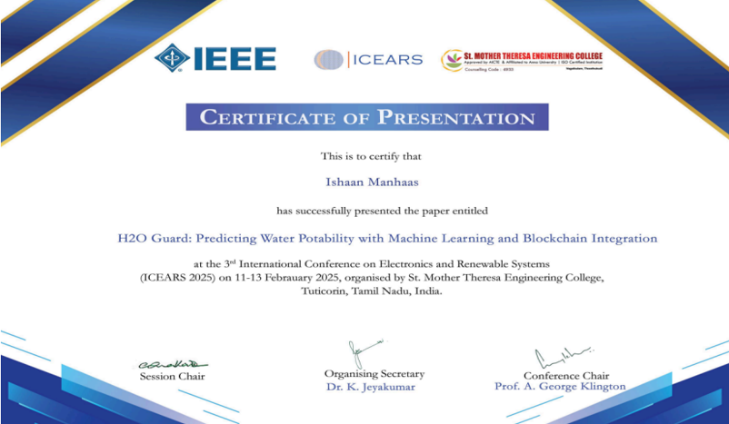

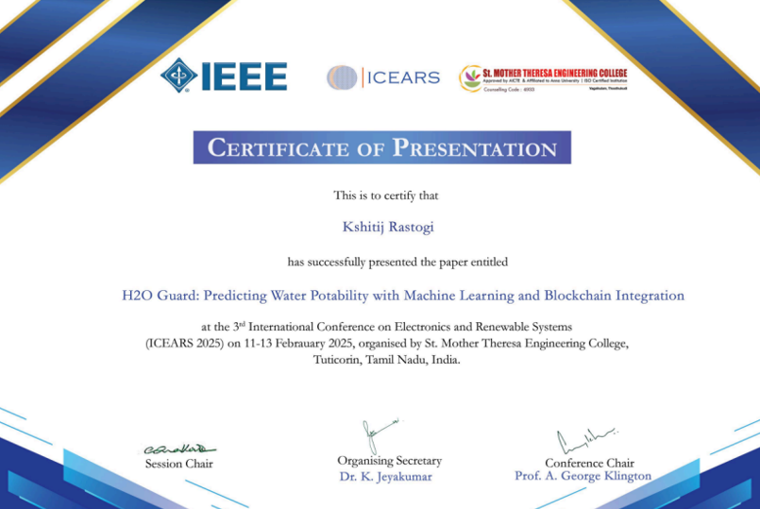

|  |  |
| --- | --- |
| **Plagiarism Details** |  |
| **Plagiarism Percentage (Research Paper)** | 6 % |
| **Plagiarism Percentage (Project Report)** | 7 % |
| **Plagiarism Tool Used** | *turnitin* |

*Project Report:*

